CHRISTMAS LUNCH MENU
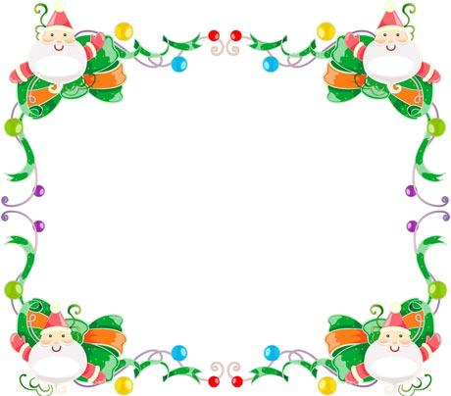

20th DECEMBER 2018

ROAST TURKEY

with
STUFFING BALLS , & PIGS in BLANKETS

FESTIVE VEGETARIAN TART

ROAST & CREAMED POTATOES

FRESH CARROT BATONS
FRESH BRUSSELS SPROUT
GARDEN PEAS
CAULIFLOWER CHEESE

CHRISTMAS COOKIES

MINCE PIES
CHRISTMAS ICE CREAM

———————————————————————————————————————————-

IF YOUR CHILD WISHES TO JOIN US FOR CHRISTMAS LUNCH, PLEASE BOOK YOUR CHILD’S CHOICE OF MEAL ON THE BOOKING SYSTEM. https://charlesdarwincp.parentseveningsystem.co.uk/
IF YOUR CHILD IS IN RECEPTION, Y1, Y2 OR IS IN RECEIPT OF FREE SCHOOL MEALS THIS MEAL IS FREE OF CHARGE OTHERWISE PLEASE MAKE SURE YOUR CHILD’S ACCOUNT IS TOPPED UP.
SCHOOL LUNCHES ARE £2.30

